1. **Create a script that asks for user name then send a greeting to him.**

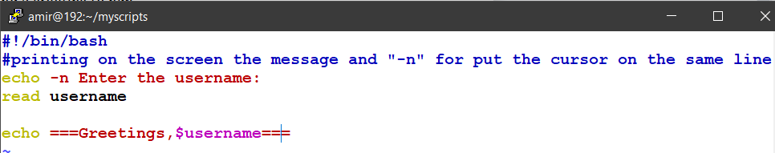

**The o/p:**

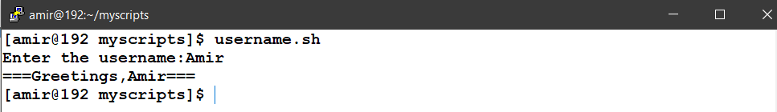

**2. Create a script called s1 that calls another script s2 where:**

**a. In s1 there is a variable called x, it's value 5**

**b. Try to print the value of x in s2 by two different ways.**

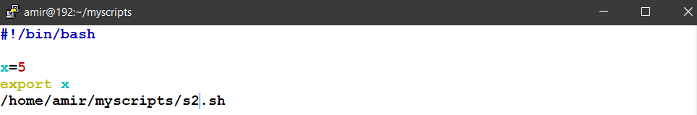

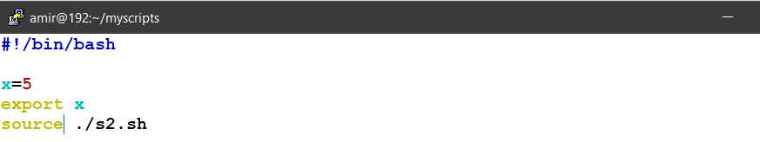

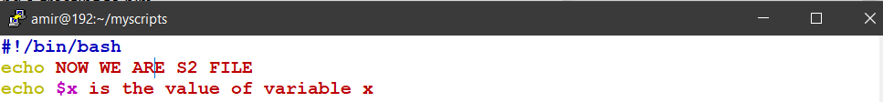

**The o/p:**

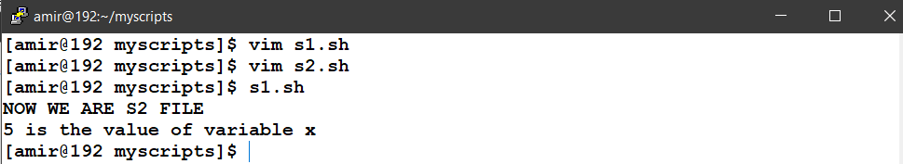

**3. Create a script called mycp where:**

**a. It copies a file to another**

**b. It copies multiple files to a directory.**

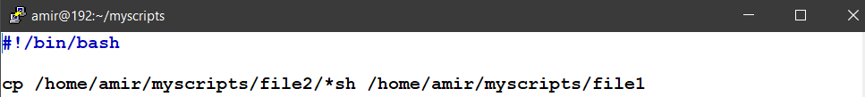

**The o/p:**

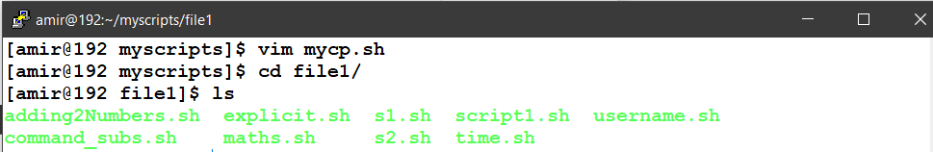

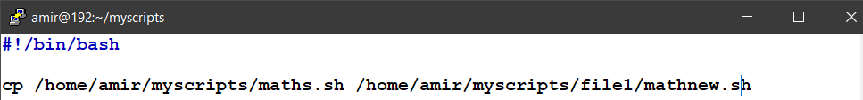

**4. Create a script called mycd where:**

**a. It changed directory to the user home directory, if it is called without arguments.**

**b. Otherwise, it change directory to the given directory.**

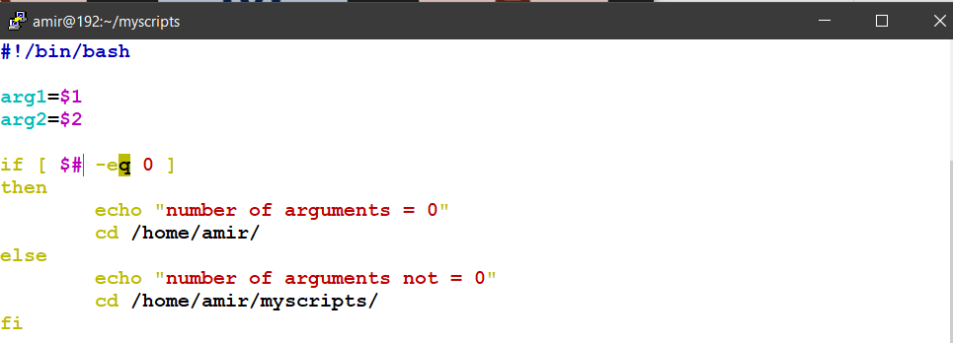

**5. Create a script called myls where:**

**a. It lists the current directory, if it is called without arguments.**

**b. Otherwise, it lists the given directory.**

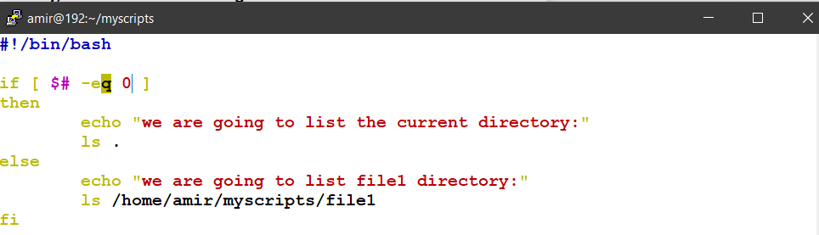

The o/p:

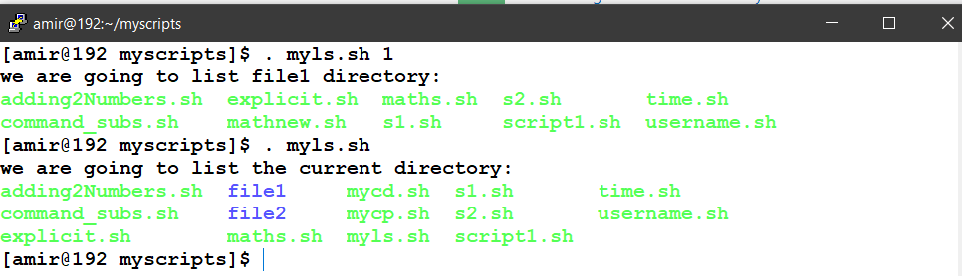

**6. Enhance the above script to support the following options individually:**

**a. –l: list in long format**

**b. –a: list all entries including the hiding files.**

**c. –d: if an argument is a directory, list only its name**

**d. –i: print inode number**

**e. –R: recursively list subdirectories**

A)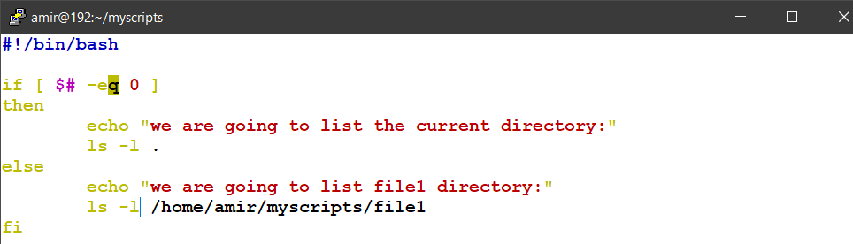

B)

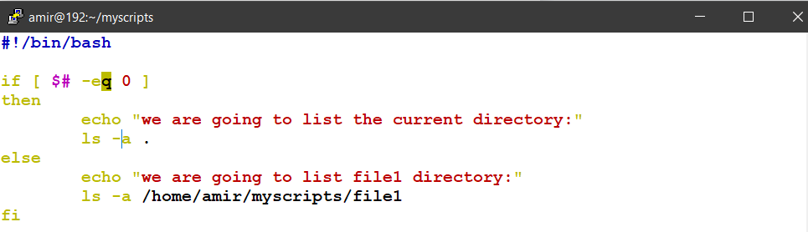

C)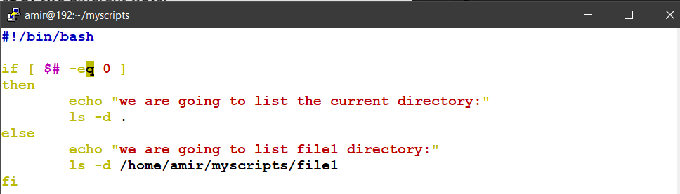

D)

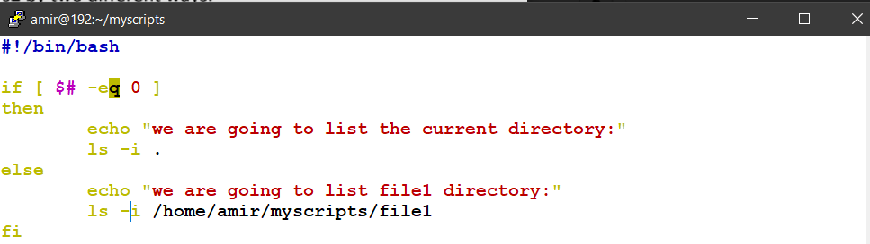

E)

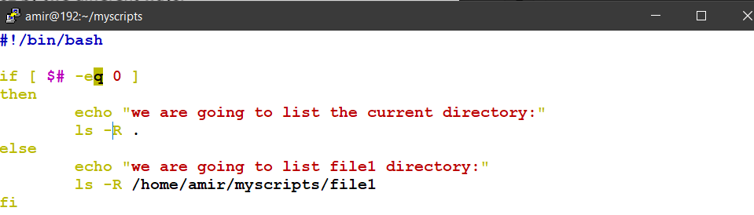

**7. Create a script called mytest where:**

**a. It check the type of the given argument (file/directory)**

**b. It check the permissions of the given argument (read/write/execute)**

A)

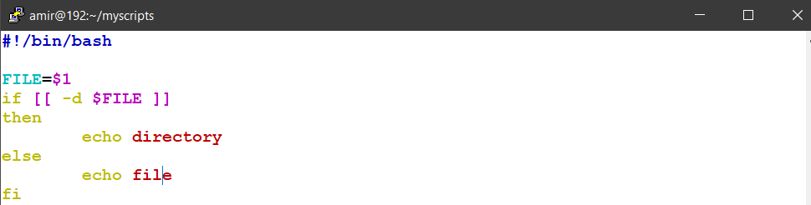

B)

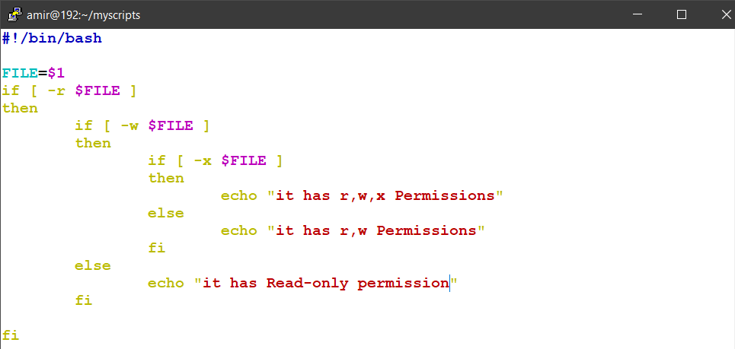

**8. Create a script called myinfo where:**

**a. It asks the user about his/her logname.**

**b. It print full info about files and directories in his/her home directory**

**c. Copy his/her files and directories as much as you can in /tmp directory.**

**d. Gets his current processes status.**

